Grade:IV Addition
How to check the answer of an addition sum?
From the sum, subtract the first ADDEND.
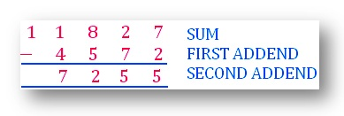
The answer of this subtraction will be the second addend.
We can even subtract the second ADDEND from the SUM to get the first ADDEND.
